# Michael Chillemi

# 05/26/2023

# CS 590 - Algorithms

# M1.C1: Module 1 Analyzing Algorithms Reinforcement Exercises

Problem 1.6.7

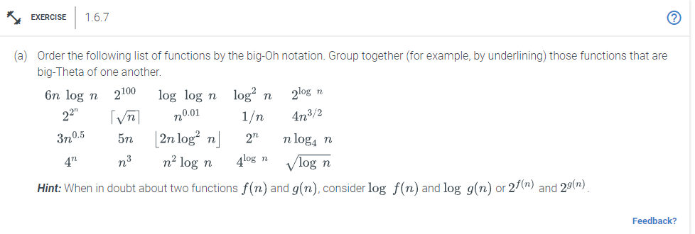

Answer:

$\frac{1}{n}$

$2^{100}$

$log log n$

$\sqrt{log^{}n}$

$log^{2}n$

$n^{0.01}$

3. $\sqrt{n}$, $3n^{0.5}$
4. $2^{log n}$, $5n$
5. ${nlog}_{4}(n)$, $6nlog n$

$2nlog^{2}n$

$4n^{\frac{3}{2}}$

$4^{log n}$

$n^{2}log n$

$n^{3}$

$2^{n}$

$4^{n}$

$2^{2^{n}}$

Problem 1.6.9

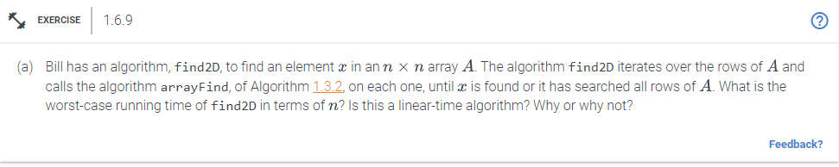

Answer:

The worst-case running time of find2D in terms of n is O($n^{2}$). This is the case because arrayFind algorithm has a O($n$) worst-case running time. Bill’s algorithm find2D runs and calls arrayFind O($n$) times. Thus O($n$) * O($n$) = O($n^{2}$). Since the input value would be an array we would consider this to be a quadratic time algorithm.

Problem 1.6.22

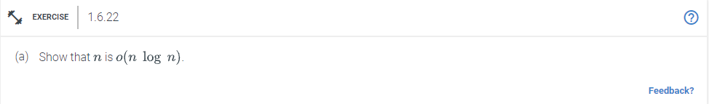

Answer:

To show that $n is O(n log n)$

We know that $f(n) is o(g(n))$ if $\lim_{n→∞}\frac{f(n)}{g(n)}$ is a finite value

Herewe can prove it by applying L’Hopitsals rule:

$f(n) = n$ and $g(n) = n log n$

$\lim_{n→∞}\frac{n}{n log n} = \lim_{n→∞}\frac{1}{log n}= 0$

Which is a finite value

Hence $n is O(n log n)$